**Design Thinking Project Workbook**

**11. Team**

**Team Name: NA**

**Team Logo (if any):NA**

**Team Members:**

1. Name: Bandla Rushith Sai,

Roll No: 2320030197

Contact: 9550856789

1. Name: S. Rithik Reddy

Roll No: 2320030094

Contact: 9100660817

1. Name: L. Sai Srikar

Roll No: 2320030449

Contact: 8309200962

**2. Problem/Opportunity Domain**

**Domain of Interest:** The domain of interest for the topic "Personal Finance and Budgeting Machine Learning Model Concept" encompasses the application of machine learning techniques to analyze financial data, predict spending patterns, and optimize budgeting strategies. This domain aims to enhance individual financial decision-making by providing personalized insights and recommendations, ultimately promoting better financial health and management. It integrates aspects of data science, behavioral finance, and consumer psychology.

**Description of the Domain:** The Personal Finance and Budgeting Machine Learning Model aims to enhance individual financial management through advanced technologies. By integrating real-time monitoring, facial recognition, data privacy, and automation, this model seeks to provide users with a comprehensive and secure tool for managing their finances.

* **Real-time monitoring:** The model continuously tracks users' financial transactions and spending patterns.
* **Facial recognition:** Utilizes facial recognition technology to authenticate users securely.
* **Data privacy and security:** Adheres to data protection regulations (like GDPR) to ensure user privacy.
* **Automation of manual processes:** Automates repetitive tasks such as expense tracking, bill payments, and budgeting adjustments.

**Benefits:**

* **Enhanced Financial Awareness:** Users gain insights into their spending habits and financial health.
* **Improved Security:** Facial recognition and strong data privacy measures protect user information.
* **Time-Saving:** Automation allows users to focus on strategic financial planning rather than manual tracking.
* **Informed Decision-Making:** Real-time data and analytics empower users to make better financial choices.

**Why did you choose this domain?:** We chose the domain of Personal Finance and Budgeting Machine Learning Model because of the growing importance of financial literacy, as many individuals struggle with managing their finances effectively amidst increasing complexity in financial products and services; the rapid development of machine learning and AI technologies offers innovative solutions to traditional financial management challenges, making this domain particularly relevant as it leverages advancements to enhance user experience and decision-making by providing real-time insights that users seek for immediate feedback on their spending habits, while addressing significant security concerns through robust data privacy measures in response to the rise of digital transactions; furthermore, automating manual financial processes saves users time and reduces errors, aligning with broader trends toward automation, and the potential for personalization through machine learning can tailor financial advice and budgeting strategies to individual users, enhancing engagement and effectiveness, all of which reflect a growing market demand for personal finance applications and tools, indicating strong interest and potential for innovation in this space.

**3. Problem/Opportunity Statement**

**Problem Statement:** Many people struggle to manage their personal finances effectively. For instance, a working professional may find it difficult to track monthly expenses, leading to overspending and unexpected debt. With complex financial products and limited understanding of budgeting, they often resort to manual tracking methods that are time-consuming and prone to errors, resulting in stress and anxiety about their financial situation.

**Problem Description:** Individuals often struggle with personal finance management due to a lack of financial literacy and complex financial products. Manual tracking methods can be time-consuming and error-prone, leading to overspending and financial stress. Additionally, concerns about data privacy hinder the use of digital tools. There is a clear need for a machine learning solution that automates real-time expense tracking, provides personalized budgeting advice, and ensures strong security, helping users manage their finances more effectively.

**Context (When does the problem occur):** The problem of ineffective personal finance management occurs during key life events such as monthly budgeting, unexpected expenses, significant life changes (like starting a new job or having children), end-of-year tax preparation, and the transition to digital banking, where individuals often struggle to adjust their financial strategies and face concerns about data security and privacy.

**Alternatives (What does the customer do to fix the problem):** To address the challenges of personal finance management, customers often resort to alternatives such as manually tracking expenses using spreadsheets or pen and paper, relying on basic budgeting apps that lack advanced features, seeking advice from friends or family, attending financial literacy workshops, using envelope budgeting systems, or hiring financial advisors for personalized guidance, although these methods can be time-consuming, less efficient, or may not provide the real-time insights needed for effective decision-making.

**Customers (Who has the problem most often):**

The problem of ineffective personal finance management is most often faced by young professionals entering the workforce, families managing household budgets, college students dealing with tuition and living expenses, individuals experiencing significant life changes (such as marriage or parenthood), and those with low financial literacy who may struggle to navigate complex financial products and services. Additionally, individuals transitioning to digital banking may also encounter challenges related to budgeting and expense tracking.

**Emotional Impact (How does the customer feel):**

Customers often feel overwhelmed and stressed due to the complexities of managing their finances, leading to anxiety about their financial future. They may experience frustration from manual tracking methods that are time-consuming and prone to errors, which can result in feelings of inadequacy or lack of control. Additionally, concerns about unexpected expenses and financial security can lead to a sense of uncertainty and fear, while the inability to access effective budgeting tools may cause feelings of helplessness and dissatisfaction with their financial situation. Overall, these emotions can significantly impact their overall well-being and confidence in making financial decisions.

**Quantifiable Impact (What is the measurable impact):**

1. **High Personal Debt Levels:** A significant portion of urban households in India carry personal loans, with studies indicating that around 40% of households are in debt, often leading to financial strain.
2. **Low Savings Rate:** The household savings rate in India has been declining, with recent figures showing it around 28% of GDP, indicating a struggle to save adequately for emergencies or future goals.
3. **Limited Financial Literacy:** Approximately 76% of adults in India lack basic financial literacy skills, impacting their ability to manage budgets, savings, and investments effectively.
4. **Budgeting Challenges:** Surveys reveal that nearly 50% of Indian families do not have a formal budgeting system, resulting in overspending and financial stress.
5. **Retirement Preparedness:** A large percentage of the workforce (over 90%) is not covered by any formal retirement savings plan, leading to concerns about financial security in old age.

**Alternative Shortcomings (What are the disadvantages of the alternatives):**

1. **Manual Tracking:** Using spreadsheets or pen and paper can be time-consuming, prone to errors, and often leads to incomplete records, making it difficult to get a clear financial picture.
2. **Basic Budgeting Apps:** Many free or low-cost budgeting apps lack advanced features such as real-time tracking, personalized insights, or integration with bank accounts, limiting their effectiveness.
3. **Seeking Advice from Friends/Family:** Relying on informal advice may lead to misinformation or strategies that are not tailored to individual financial situations, potentially causing more confusion.
4. **Financial Literacy Workshops:** While helpful, these workshops may not provide ongoing support or practical tools, leaving participants without actionable strategies for everyday financial management.
5. **Envelope Budgeting System:** This method can be restrictive and impractical in a digital economy, making it challenging to adapt to modern spending habits.
6. **Hiring Financial Advisors:** Professional advice can be costly and may not be accessible to everyone, particularly those with lower incomes or simpler financial needs.

**4. Addressing SDGs**

**Relevant Sustainable Development Goals (SDGs):**

* **SDG 11: Sustainable Cities and Communities:** Promotes inclusive and sustainable urban environments by enhancing financial literacy and stability.
* **SDG 1: No Poverty:** Empowers individuals to manage resources effectively, reducing poverty.
* **SDG 4: Quality Education:** Enhances financial education for better management skills.
* **SDG 8: Decent Work and Economic Growth:** Supports economic growth through informed financial decision-making.

**How does your problem/opportunity address these SDGs?:**

* **SDG 11**: Enhances financial literacy, reducing stress and fostering resilience, Encourages resource allocation towards eco-friendly practices.
* **SDG 9**: By offering tailored budgeting tools, it helps entrepreneurs manage finances more effectively, promoting business growth and sustainability.

**5. Stakeholders**

Answer these below questions to understand the stakeholder related to your project

1. **Who are the key stakeholders involved in or affected by this project?**

* **Campus security teams**: May be involved in protecting sensitive financial data and ensuring that the budgeting model adheres to privacy and security protocols.
* **College administration**: esponsible for approving the project, allocating funding, and ensuring the model aligns with institutional objectives and policies.
* **Students and staff**: The primary users of the personal finance and budgeting model, their needs and feedback will shape the model's features and usability.
* **IT and technical staff**: Tasked with developing, implementing, and maintaining the machine learning model, ensuring it integrates effectively with existing systems and provides reliable performance.

1. **What roles do the stakeholders play in the success of the innovation?**

* **Campus security teams** Ensure data security and privacy compliance, protecting sensitive financial information from breaches.
* **College administration** Facilitate project approval and funding allocation, ensuring resources are available for development and implementation.
* **Students and staff** Actively engage with the model, influencing its success through participation and advocacy within the community.
* **IT staff** Develop and maintain the machine learning model, ensuring its reliability, performance, and integration with existing systems.

1. **What are the main interests and concerns of each stakeholder?**

* **Campus security teams**:

**Interests:** Ensuring data security and compliance with regulations.

**Concerns:** Risks of data breaches and unauthorized access to sensitive financial information.

* **College administration**:

**Interests:** Successful implementation of the model to enhance student financial literacy and institutional reputation.

**Concerns:** Budget constraints, alignment with institutional goals, and potential backlash from stakeholders if the project fails.

* **Students and staff**:

**Interests:** User-friendly tools for managing personal finances and budgeting effectively.

**Concerns:** Privacy of their financial data, ease of use, and whether the model truly meets their needs.

* **IT staff**:

**Interests:** Technical feasibility and successful integration of the model with existing systems.

**Concerns:** Resource allocation, potential technical challenges, and ongoing maintenance requirements.

1. **How much influence does each stakeholder have on the outcome of the project?**

**Campus Security Teams**: High influence due to their role in ensuring data protection.

**College Administration**: High influence as they control funding and project approval.

**Students and Staff**: Moderate influence through feedback and adoption rates.

**IT Staff:** High influence as they are responsible for the development and implementation of the model.

1. **What is the level of engagement or support expected from each stakeholder?**

**Campus Security Teams**: Active involvement in security assessments and compliance checks.

**College Administration**: Support in terms of funding, policy alignment, and promotion of the initiative.

**Students and Staff**: Expected to engage actively, providing feedback and participating in training sessions.

**IT Staff**: Continuous engagement in development, troubleshooting, and user support.

1. **Are there any conflicts of interest between stakeholders? If so, how can they be addressed?**

**Potential Conflicts:**

Students may prioritize usability over data security, while security teams may enforce stringent measures that complicate user experience.

Administration may focus on cost-effectiveness, which could conflict with IT staff's need for adequate resources.

**Addressing Conflicts:** Regular stakeholder meetings to discuss concerns, align priorities, and find a balance between security, usability, and resource allocation.

1. **How will you communicate and collaborate with stakeholders throughout the project?**

**Regular Updates**: Scheduled meetings and progress reports to keep stakeholders informed.

**Feedback Mechanisms**: Surveys and focus groups to gather input from students and staff.

**Collaboration Tools**: Use of project management software to facilitate communication among IT staff and administration.

1. **What potential risks do stakeholders bring to the project, and how can these be mitigated?**

**Data Security Risks**: Implement robust security protocols and conduct regular audits.

**Budget Constraints**: Seek additional funding or partnerships to ensure financial sustainability.

**Resistance to Change:** Provide training and support to ease the transition and demonstrate the model's benefits.

**6. Power Interest Matrix of Stakeholders**

**Power Interest Matrix:**

**High Power, Low Interest (Keep Satisfied)**

Campus Security Teams

**High Power, High Interest (Manage Closely)**

Campus Administration

**Low Power, Low Interest (Monitor)**

General Public

**Low Power, High Interest (Keep Informed)**

Students and Staff

high

high

low

low

INFLUENCE

INTEREST

A[High Power, High Interest] -->|Campus Administration| B[IT Staff]

C[High Power, Low Interest] -->|Campus Security Teams|

D[Low Power, High Interest] -->|Students and Staff|

E[Low Power, Low Interest] -->|General Public|

**7.Empathetic Interviews**

**Conduct Skilled interview with at least 30 citizens/Users by asking open ended questions (What, why/How etc) and list the insights as per the format below**

|  |  |  |
| --- | --- | --- |
| **I need to know**  **(thoughts, feelings, actions)** | **Questions I will ask**  **(open questions)** | **Insights I hope to gain** |
| Thoughts | What are your biggest challenges in managing your finances? | Understanding specific pain points in personal finance. |
|  |
| Feelings | How do you feel about using technology for budgeting? | Gauging emotional responses to tech solutions. |
|  |
| actions | What tools do you currently use for budgeting? | Identifying existing habits and preferences. |
|  |

**SKILLED INTERVIEW REPORT**

|  |  |  |
| --- | --- | --- |
| **User/Interviewee** | **Questions Asked** | **Insights gained (NOT THEIR ANSWERS)** |
| Client -1 | What features would you like in a budgeting app? | Users prefer simplicity and customization options. |
| Client - 2 | How do you currently track your expenses? | Many rely on spreadsheets, indicating a need for user-friendly tools. |

**Key Insights Gained:**

* **Insight 1:** Users value ease of use and customization in budgeting tools.
* **Insight 2:** There is a strong desire for integration with existing financial accounts

**8. Empathy Map**

**a. Who is your Customer?**

* **Description:** College students aged 18-25, tech-savvy, seeking to improve financial literacy.
* **Goals and Needs:** Effective budgeting, understanding financial management, reducing debt.

**b. Who are we empathizing with?**

* **Characteristics:** Students balancing academics and part-time jobs, often anxious about financial stability.
* **Goals and Challenges:** Desire to save money while managing tuition and living expenses; often lack financial education.

**c. What do they need to DO?**

* **Tasks:** Create budgets, track spending, set financial goals.
* **Decisions:** Choosing budgeting tools, determining spending limits.
* **Success Definition:** Achieving financial stability and meeting savings goals.

**d. What do they SEE?**

* **Environment:** Financial apps, social media influencers discussing finance, peers sharing budgeting tips.
* **Influence:** Trends in personal finance management and peer recommendations.

**e. What do they SAY?**

* **Expressions:** "I wish I had a better way to manage my money." "Budgeting apps seem complicated."
* **Frustrations:** Overwhelmed by choices and lack of guidance.

**f. What do they DO?**

* **Actions:** Use spreadsheets or free apps, attend financial literacy workshops, seek advice from peers.
* **Habits:** Regularly check bank accounts but may neglect budgeting.

**g. What do they HEAR?**

* **Sources:** Friends discussing financial struggles, online tutorials, marketing from financial apps.
* **Influencers:** Financial bloggers or YouTubers promoting budgeting techniques.

**h. What do they THINK and FEEL?**

* **Fears:** Fear of debt and financial mismanagement.
* **Motivations:** Desire for financial independence and security.

**i. Pains and Gains**

* **Pains:** Confusion over financial jargon, difficulty sticking to budgets.
* **Gains:** Achieving savings goals, feeling empowered in financial decisions.

**9. Persona of Stakeholders**

**Stakeholder Name:** College Student  
**Demographics:** 20 years old, undergraduate, part-time worker, income: $1,000/month.  
**Goals:** Improve financial literacy, save for future expenses, manage student loans effectively.  
**Challenges:** Limited financial education, balancing studies with work, managing living expenses.  
**Aspiration:** Achieve financial independence post-graduation.  
**Needs:** User-friendly budgeting tools, education on financial management.  
**Pain Points:** Overwhelmed by financial decisions, lack of personalized financial advice.  
**Storytelling:** A college student struggles to manage monthly expenses while studying, often feeling lost in financial decisions. The budgeting model can provide tailored advice, helping them make informed choices and build savings.

**10. Look for Common Themes, Behaviors, Needs, and Pain Points among the Users**

* **Common Themes:** Need for financial education, desire for user-friendly tools, importance of security in financial transactions.
* **Common Behaviors:** Regularly monitor finances but struggle with budgeting.
* **Common Needs:** Simplified budgeting processes, integration with existing financial accounts.
* **Common Pain Points:** Confusion over financial options, fear of overspending.

**12. Define Needs and Insights of Your Users**

* **User Needs:**
  + Simple and intuitive budgeting tools.
  + Education on financial management.
  + Security and privacy in financial data handling.
* **User Insights:**
  + Users are eager for solutions that simplify financial management.
  + There is a strong demand for personalized advice and support.

**13. POV Statements**

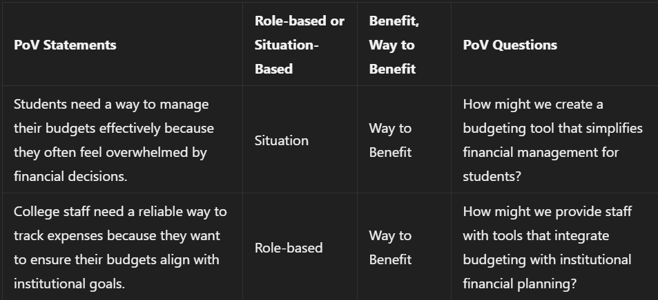

**14. Develop POV/How Might We (HMW) Questions**

1. How might we create a budgeting tool that is easy to use for students?
2. How might we educate students on financial literacy through the model?
3. How might we ensure the security of user data while providing personalized financial advice?
4. How might we encourage students to adopt budgeting practices consistently?
5. How might we integrate the budgeting model with existing financial services?

**16. Crafting a Balanced and Actionable Design Challenge**

**Design Challenge:** Develop a user-friendly personal finance and budgeting machine learning model that enhances financial literacy among college students while ensuring data security and privacy.

**19. Ideation**

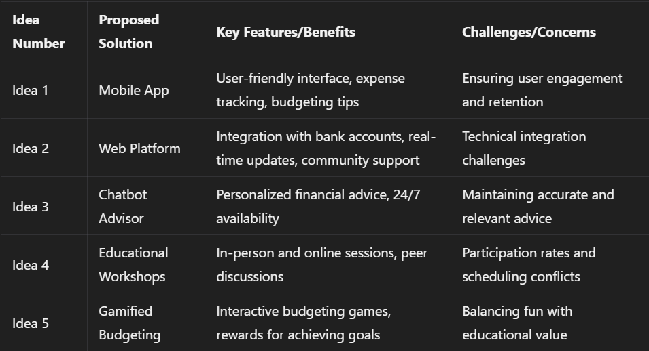

**19. Idea Evaluation**

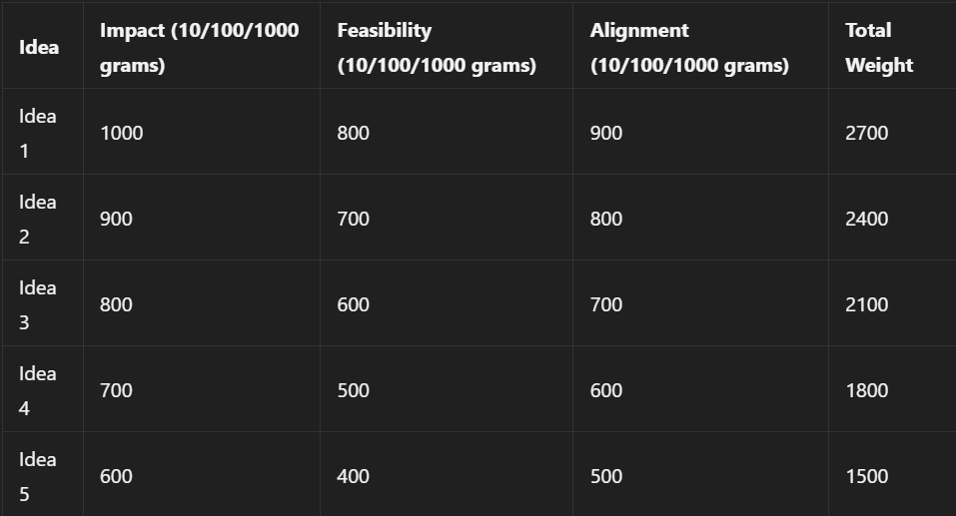

**Solution Concept Form:**

1. **Problem Statement:** Many college students struggle with personal finance management due to a lack of financial education and user-friendly tools.
2. **Target Audience:** College students aged 18-25 seeking to improve their financial literacy and budgeting skills.
3. **Solution Overview:** A machine learning-based personal finance and budgeting model that provides tailored financial advice and budgeting tools.
4. **Key Features:**
   * **Feature 1:** Personalized budgeting recommendations based on spending habits.
   * **Feature 2:** Integration with bank accounts for real-time tracking.
   * **Feature 3:** Educational resources on financial management.
5. **Benefits:**
   * **Benefit 1:** Empowers students to take control of their finances.
   * **Benefit 2:** Reduces financial stress through effective budgeting.
   * **Benefit 3:** Enhances financial literacy and decision-making skills.
6. **Unique Value Proposition (UVP):** A comprehensive and user-friendly platform that combines personalized financial advice with education, tailored specifically for college students.
7. **Key Metrics:**
   * **Metric 1:** User engagement rates (daily/weekly active users).
   * **Metric 2:** Improvement in users' budgeting skills as measured by surveys.
8. **Feasibility Assessment:** The solution is achievable with existing technology, but requires collaboration with financial institutions for integration.
9. **Next Steps:** Conduct further user research, develop a prototype, and initiate a pilot program.